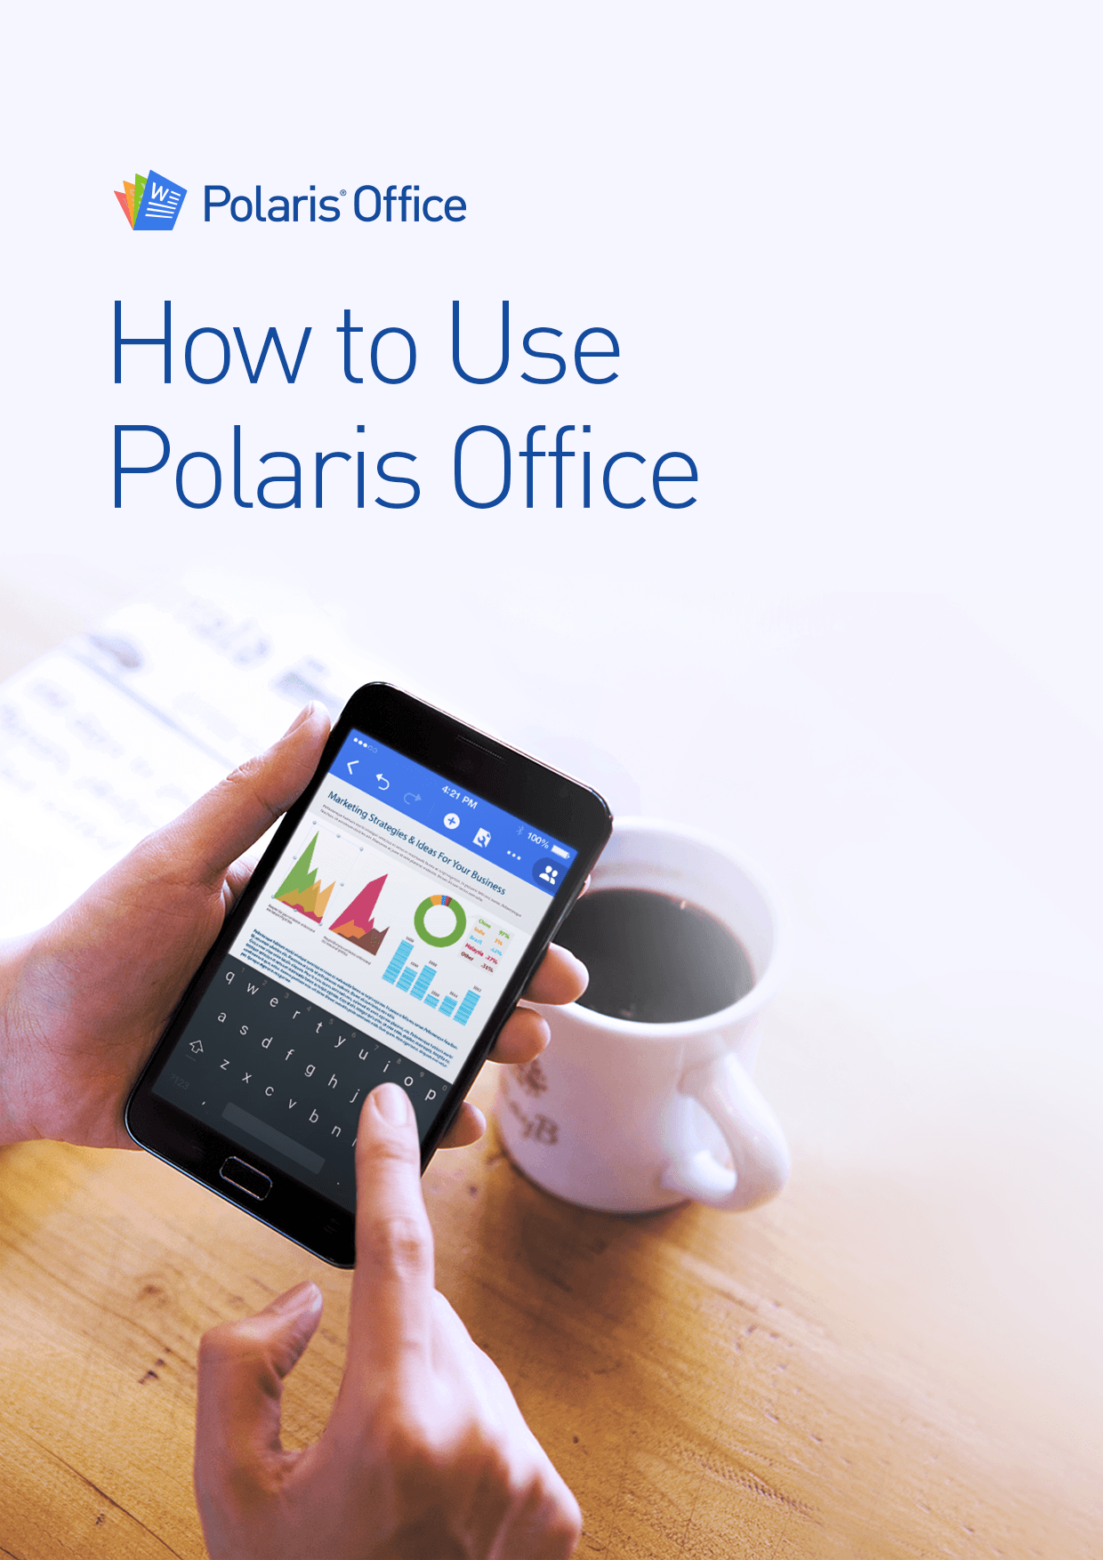

Polaris Office User Guide

1. How to use Polaris Office 3

2. Import Documents 4

**1)** **Desktop** 4

**2)** **External storage or other clouds(mobile)** 5

**3)** **Email attachments(mobile)** 6

**4)** **New Document** 7

3. View & Edit 8

**1)** **View/Edit Mode** 8

**2)** **How to view** 8

**3)** **How to edit** 9

4. Manage your files 10

**1)** **How to sync/upload** 10

**2)** **How to search** 11

**3)** **Last viewed page(mobile)** 11

**4)** **Document's version(website)** 12

5. How to share 12

**1)** **Contact List** 13

**2)** **Share by URL Link** 13

**3)** **Custom Mode** 14

**4)** **Email attachments** 15

1. **How to use Polaris Office**

* Polaris Office provides many useful templates that people use often to help them manage their documents anytime anywhere.
  + To download, please click the link below(mobile/desktop)  
    - <https://www.polarisoffice.com/download>

|  |  |
| --- | --- |
| **Mobile** | |
| **iOS** | - A mobile office application for iPhone and iPad users  - Available for download from the Apple App Store |
| **Android** | - A mobile office application for Android phones and tablets  - Available for download on the Google Play Store  **\* Also available for download on Amazon, Yandex and other app stores** |

|  |  |
| --- | --- |
| **Desktop** | |
| **Sync**  **(Window/Mac)** | - Drag and drop desktop application to manage and sync your documents through Polaris Office  - Supports Windows and Macs |
| **Web** | - Website to provide you access to your documents anytime anywhere.  - Visit our website: <www.polarisoffice.com>  **\* Currently, you may only view your documents. We are to working to provide an online editing feature.** |

1. **Import Documents**

* You can import documents from your desktop and other cloud storages. Polaris Office supports MS Office/ HWP/ PDF/ Text and other various formats to provide an environment where you can easily manage your documents in one place.

1. **Desktop**

* **How to use Polaris Office Sync** – Install Polaris Office Sync and login. Designate a folder to sync with your Polaris Office account. All documents saved in that folder will be available for you to view on your mobile devices.

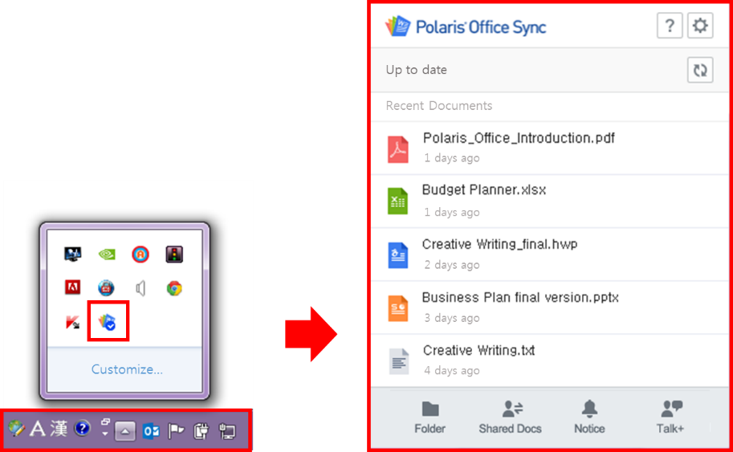

* **How to use our Website** - Visit our Polaris Office website and login. You can upload documents by clicking the “Upload" button or dragging and dropping them on the website.

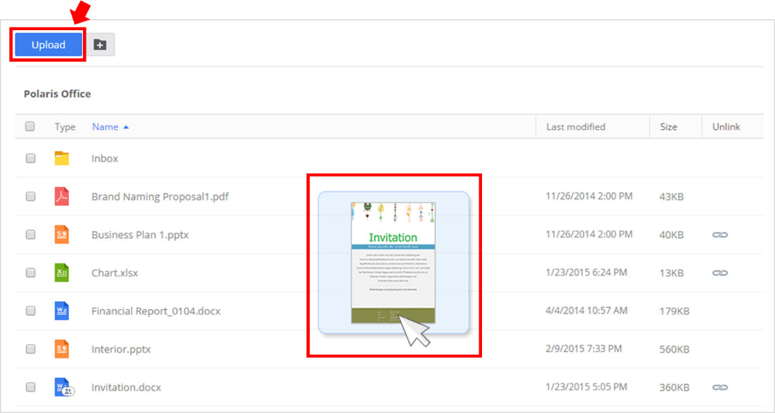

1. **External storage or other clouds(mobile)**

* For iPhones and iPads, please open our app, press "Add your Cloud(s)" located on the bottom left side of the screen. Then select the cloud that you want to open and login. You can download documents directly or "save as" in Polaris Office.   
  **\*Polaris Office will ask you to login to the cloud service you want to connect.**

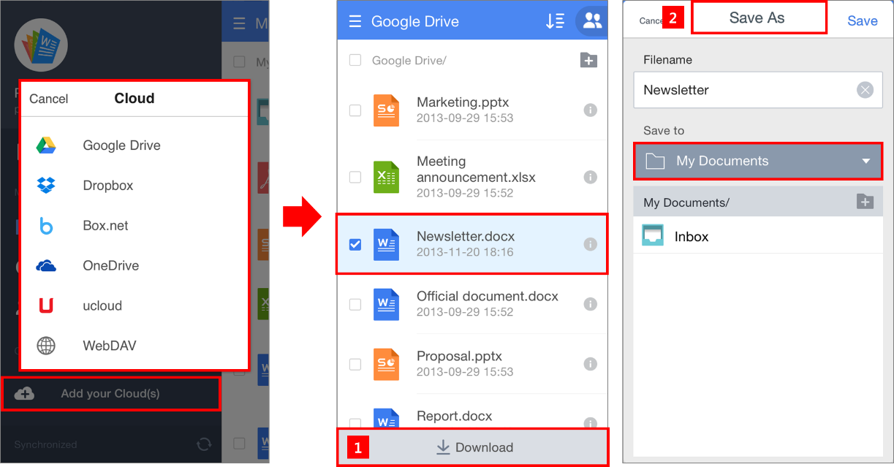

* For Androids, please open our app, press "Add cloud" located on the bottom left side of the screen, and login to connect. Press on a document for one to two seconds and select “copy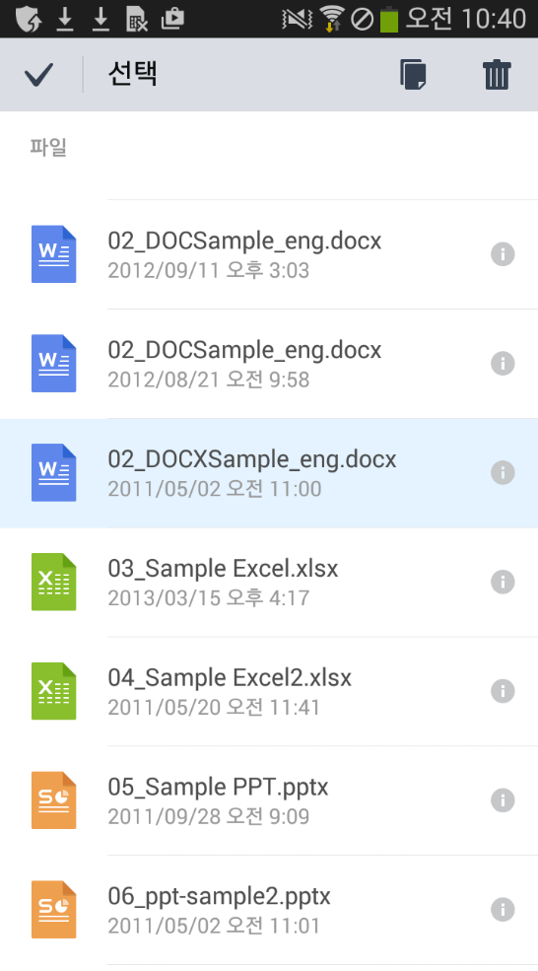” or you can “save as” to import them on your Polaris Office account.  
  **\*You can also import documents from the device's storage and external SD card using the same instructions.**

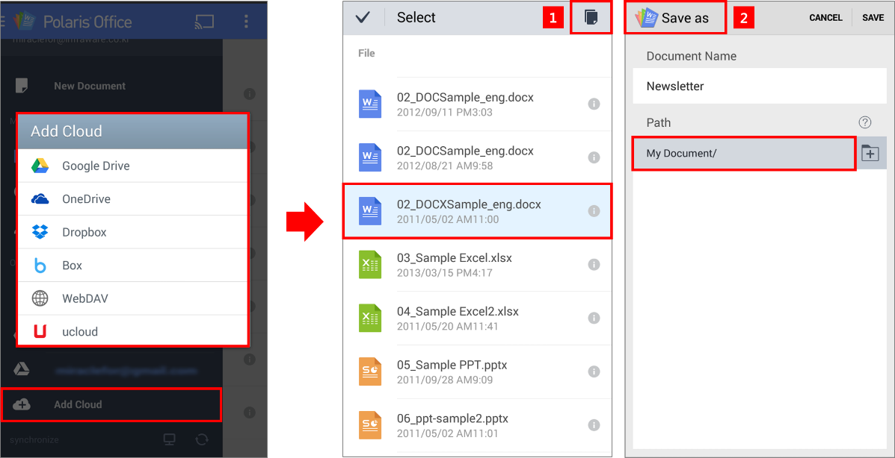

1. **Email attachments(mobile)**

* For iPhones and iPads, open the attachment from your email and press “” button and select “Open in Polaris Office”. These documents will be automatically saved in "Inbox" folder in “My Documents”.

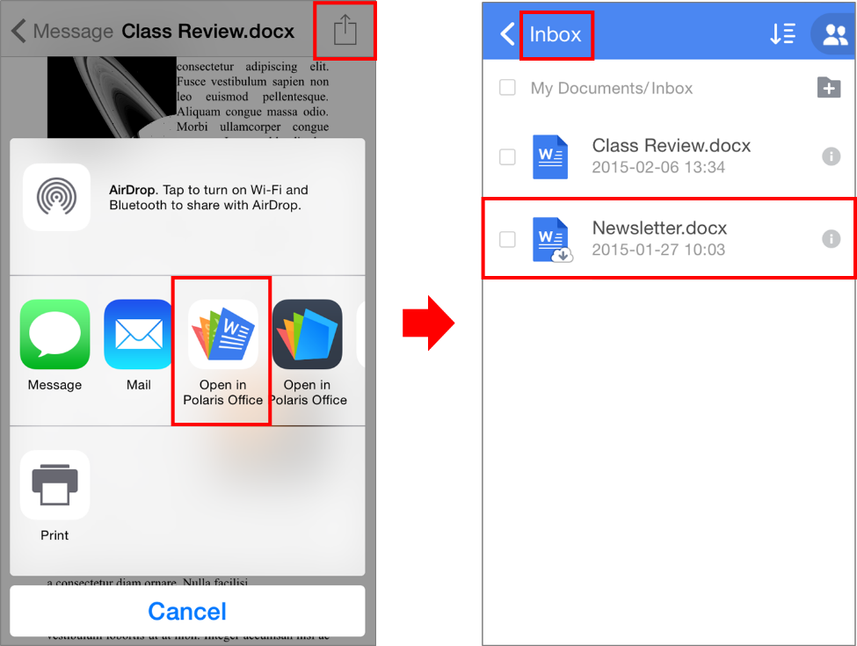

* For Androids, open the attachments and your device will download it to open it. Then select “Polaris Office” as the application you want to use. These documents will be automatically saved in "Inbox" folder in “My Documents”.

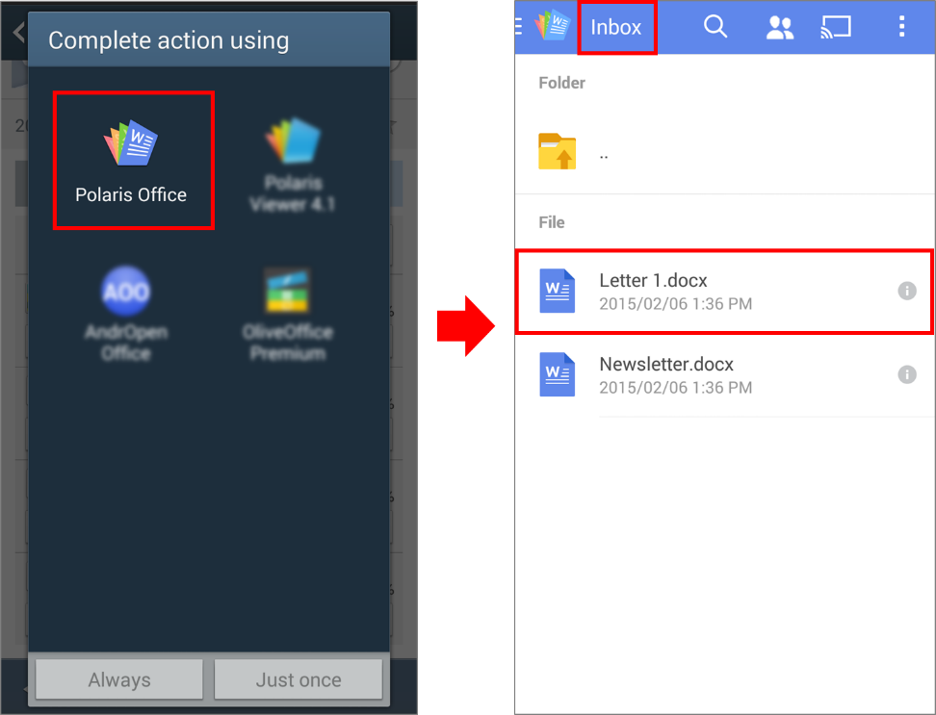

1. **New Document**

* You can create a blank, or a new document using the templates provided under “New Document”. **\*Supported formats - Word, Spreadsheets, Slides, Hwp, Text**

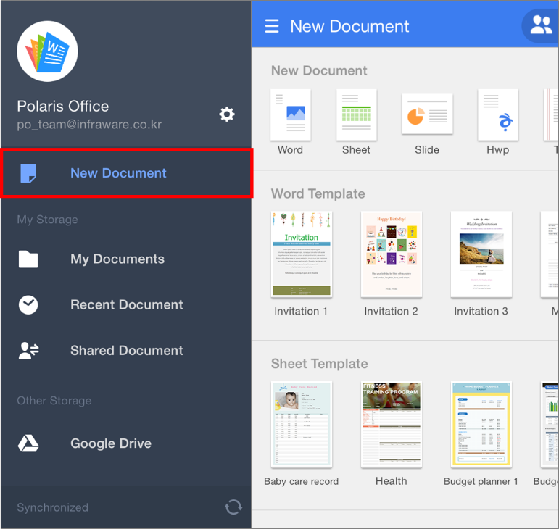

* For Android devices, please use the "+" icon located on the bottom right-hand corner to create a new document.   
  **\*Supported formats - Word, Spreadsheets, Slides, Hwp, Text**

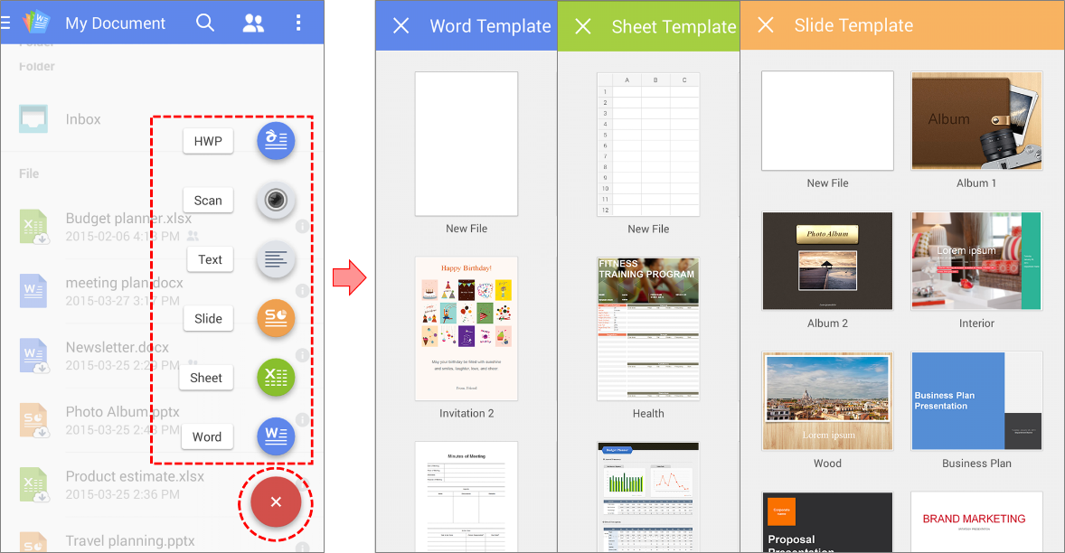

1. **View & Edit**
   1. **View/Edit Mode**

* You can slide the top bar to side ways to switch from view to edit mode and vice versa.

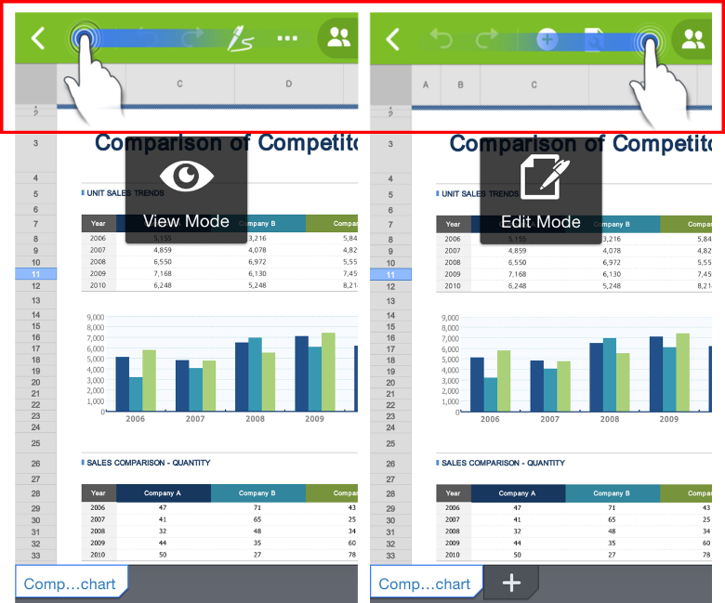

* 1. **How to view**
* “View mode” is optimized for viewing a document on your mobile device. "View mobile version" is optimized to reduce the unused area to utilize max. Area on the screen and pen annotations to handwrite notes.   
  **\*Currently “View mobile version” is only available on Androids.**

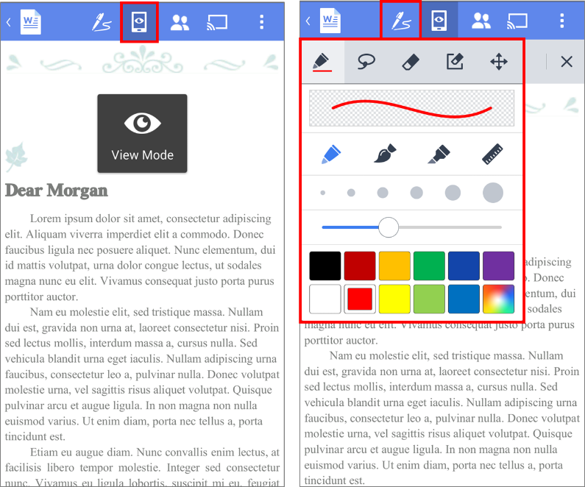

* 1. **How to edit**
* **Word** – You can change fonts, sizes and colors; as well as insert tables, images, and 170+ shapes.

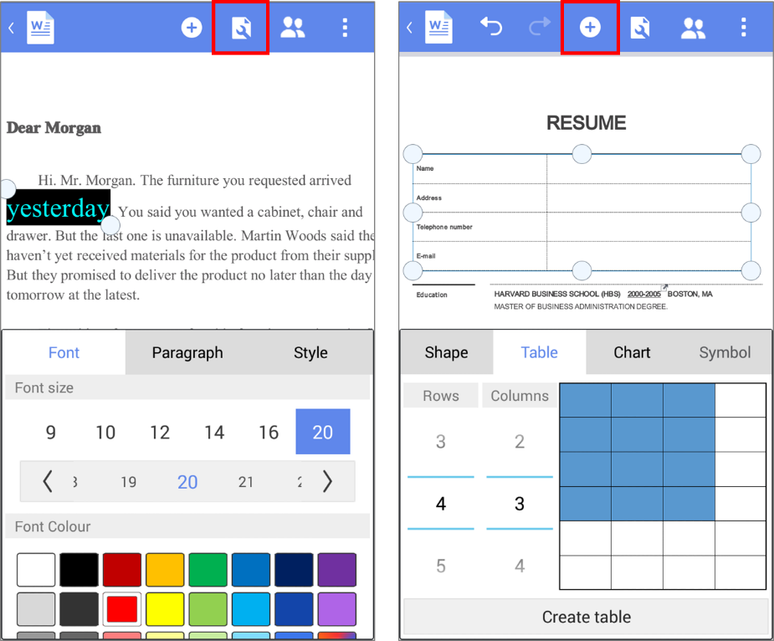

* **Sheet** – Supports more than 300 formulas and 20 2D/3D charts.

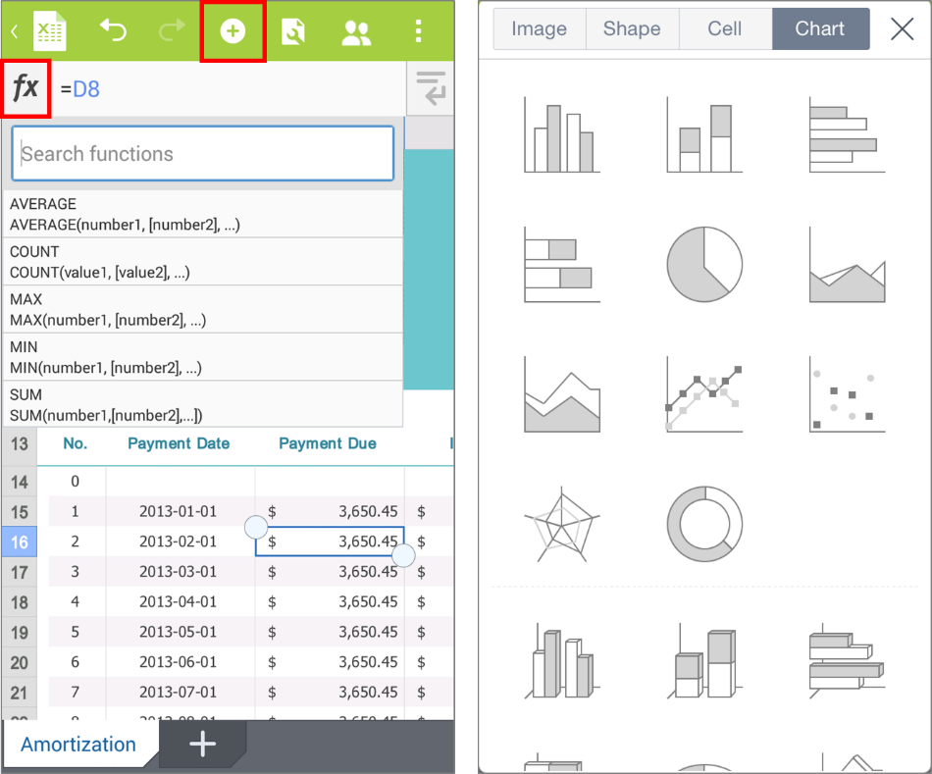

* **Slide** – Includes more than 170 shapes with different shades, reflections, 3D rotations, and 34 animations to make your presentation dynamic and memorable.

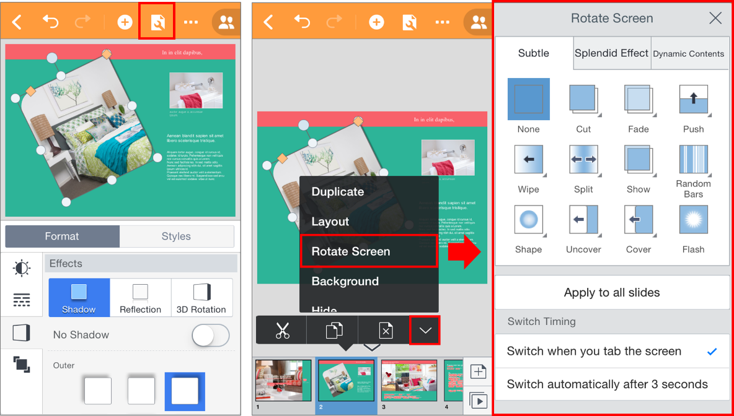

1. **Manage your files**
   1. **How to sync/upload**

* All documents in Polaris Office are available for you to access on your desktop and mobile devices. All edits are synced between connected devices.

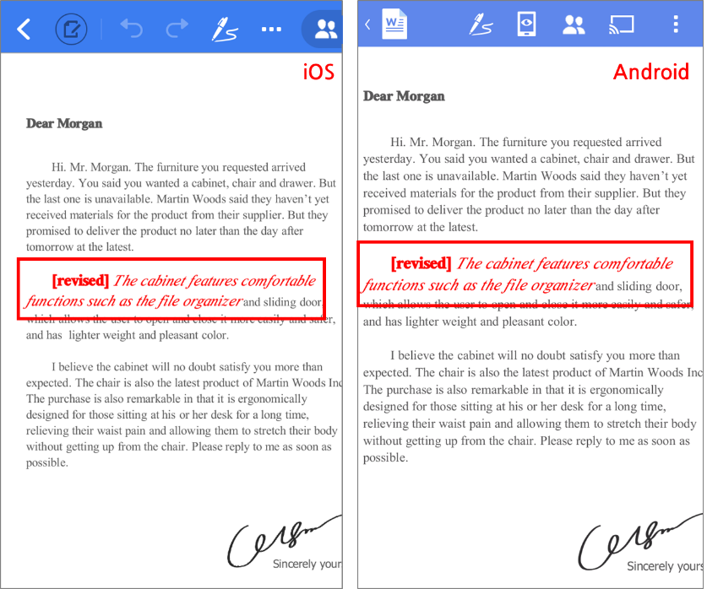

* 1. **How to search**
* When you don't recall the name of the document, you can search for keywords to search through documents' contents.   
  **\* Content Search is only available for premium service users.**

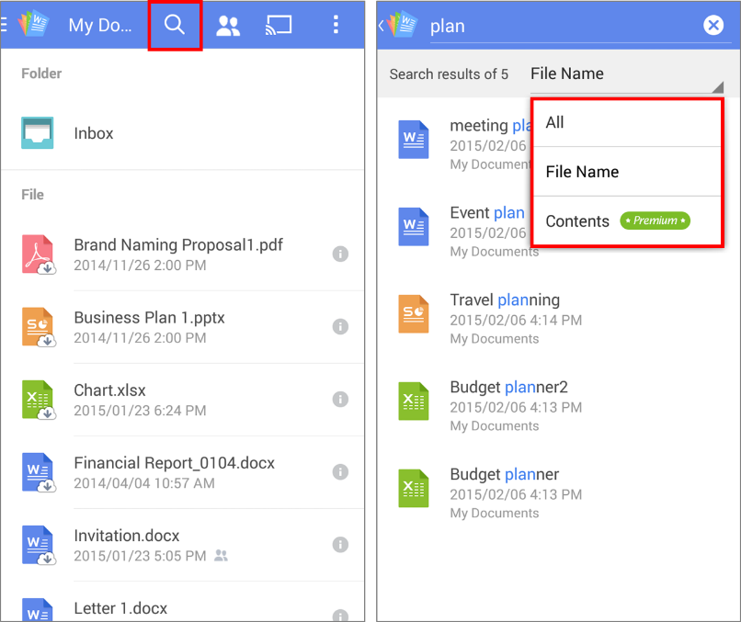

* 1. **Last viewed page(mobile)**
* Polaris Office will remember the page you viewed. For example, you can continue to read a document on an Android phone that you last viewed using an iPhone.

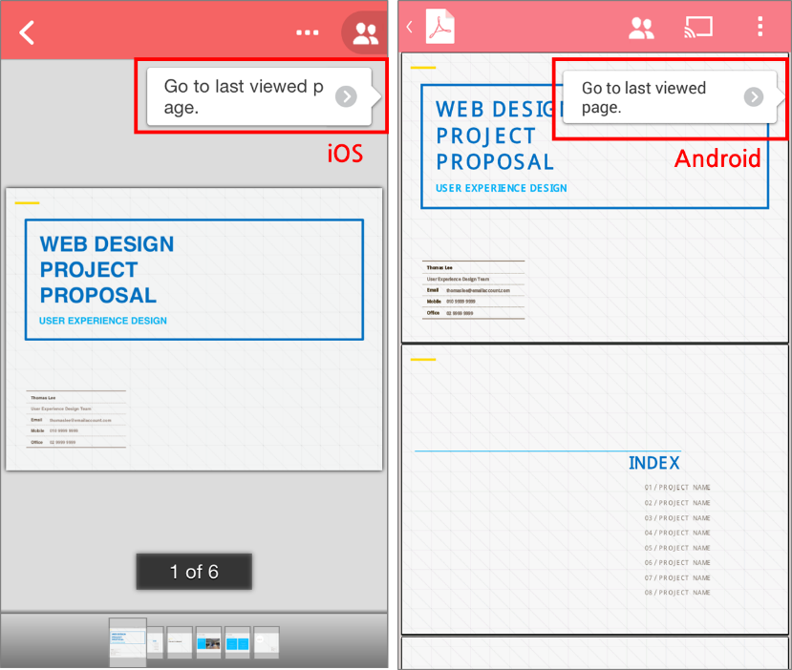

* 1. **Document's version(website)**
* When you right-click on documents from our website, you can view the documents' "version." When you click the file, you can view and download older versions of your it.   
  **\*A new version is automatically created whenever you save.**

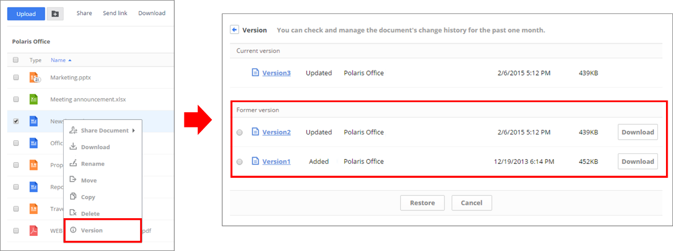

1. **How to share**

* Polaris Office provides various ways to share. Select a document from “My Documents” and tap “share”.

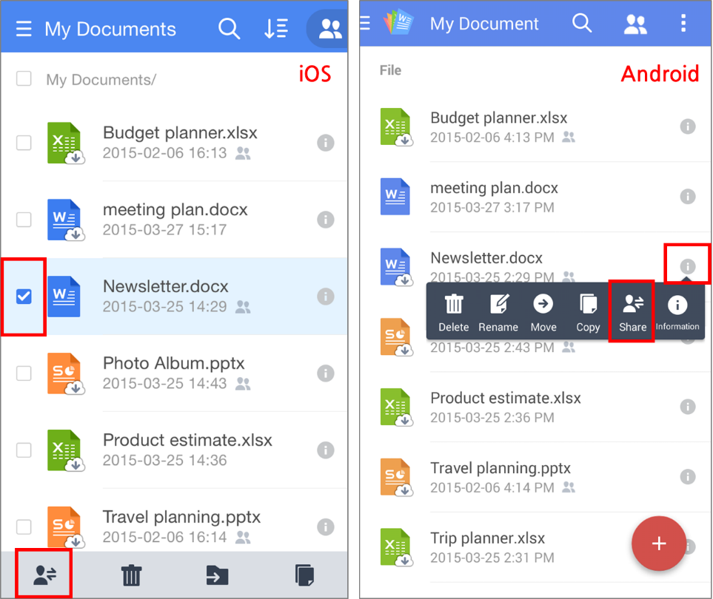

* 1. **Contact List**
* Share your documents to specific individuals you have on your contact list. You can import them from your device or other services.

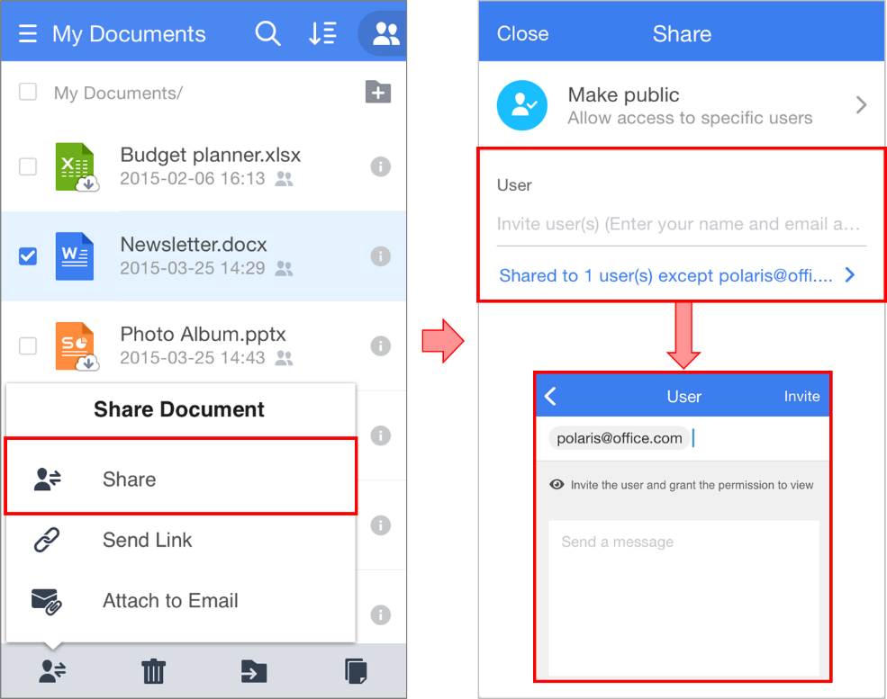

* 1. **Share by URL Link**
* Create a shareable URL link to share with others! You can also share the link on social media.

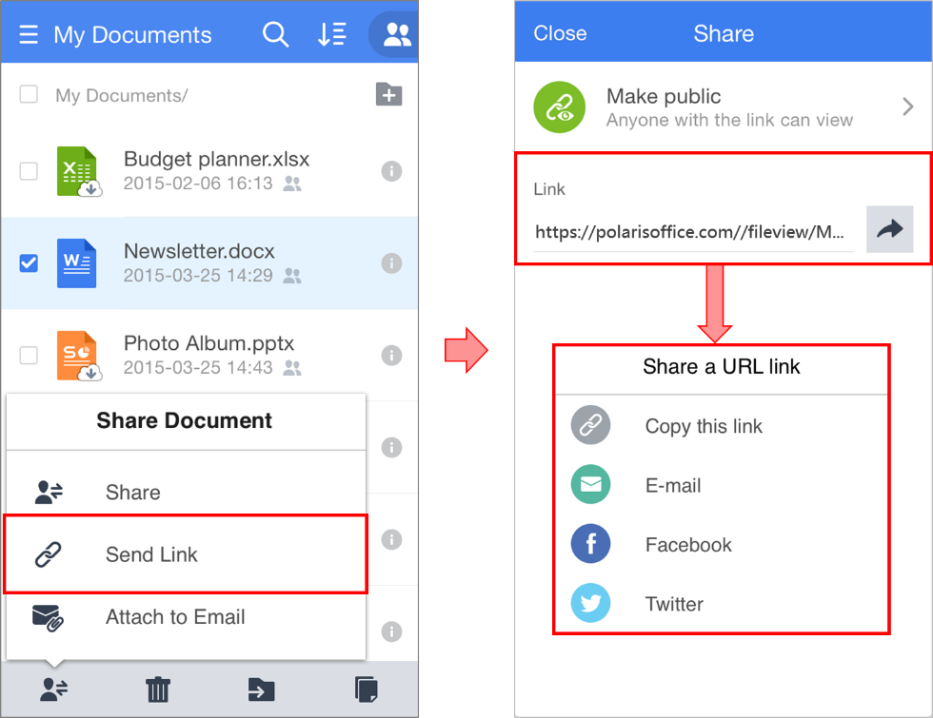

* 1. **Custom Mode**
* You can customize who you want to share with and their permissions to edit and share.

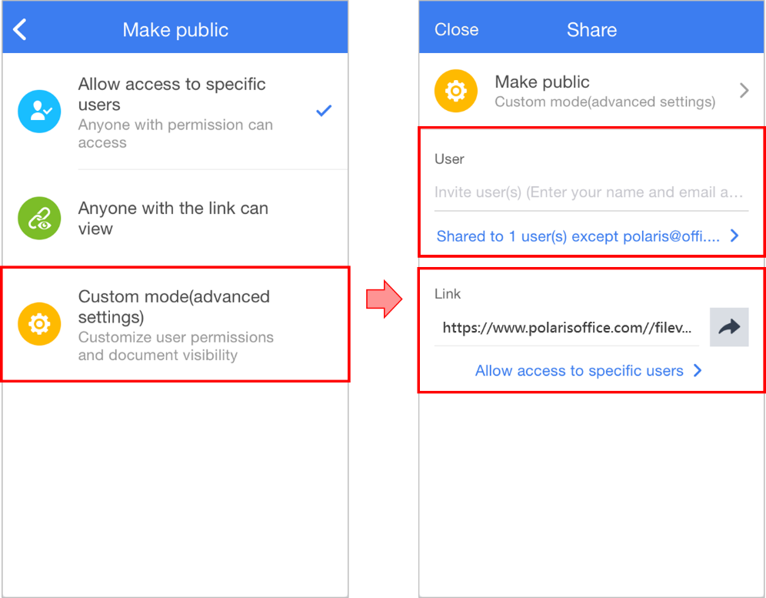

* You can check your shared documents in your Shared Documents section.

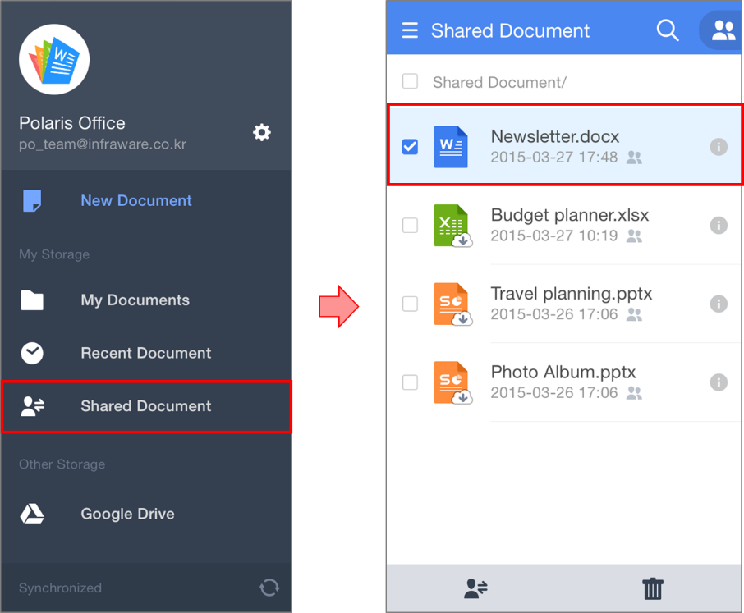

* 1. **Email attachments**
* Use "Attach to Email" to send documents using the email account you use on your device. (This may be a different email address from your Polaris Office account.)

